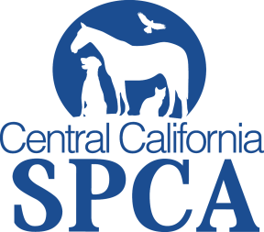 Media Contact:
Walter Salvari, CCSPCA Spokesperson
(559) 389-6224
media@ccspca.com
Press Release
June 26, 2014
WHO: Central California Society for the Prevention of Cruelty to Animals
WHAT: Adoption Fees Waived for All First Responders
WHEN: July 1 to July 13, 2014
WHERE: CCSPCA 103 S. Hughes Ave., Fresno CA 93706
WHY: In commemoration of July 4, the CCSPCA would like to express gratitude for the role that first responders play in keeping our community safe. Our adoption special is a way to say “thank you” to peace officers, fire, active military, paramedics or emergency medical technicians, and search & rescue – the Life Savers of our community.
The lessons pets teach us about love, loyalty and gratitude are those that resonate with many in the community and particularly with those who have chosen to dedicate their lives to service.
The CCSPCA is a contestant in the ASPCA Rachel Ray $100K Challenge, a contest in which 50 shelters across the country compete to break their own records saving the lives of animals. Throughout the months of June, July, and August 2014, each competing shelter must save more dogs, cats, puppies and kittens than they did during the same three months in 2013.

Our theme is “Be a Life Saver. Be a Hero. Save a Life” and we have set the goal of saving over 2,800 pets this summer!

Adoptions include the following: spay/neuter, vaccines, de-worming, microchip, Fresno City dog license (if applicable), and flea/tick treatment.

#100KChallenge #SaveALifeFresno

For more information please contact
CCSPCA at 559.233.7722 ext 107 or visit ccspca.com
Central California SPCA, 103 S. Hughes Ave., Fresno CA 93706
###

