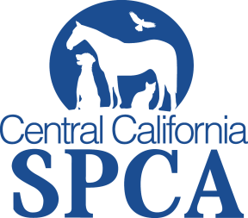 Media Contact:
Walter Salvari, CCSPCA Spokesperson
(559) 389-6224
media@ccspca.com
Press Release
June 9, 2014
WHO: Central California Society for the Prevention of Cruelty to Animals.

WHAT: Adoption Fees on ALL Cats & Dogs Reduced by 50% during June!

WHEN: June 9 to June 30, 2014

WHERE: Central California Society for the Prevention of Cruelty to Animals.

WHY: “Be a Life Saver” and help us kick-off our three month long ASPCA Rachel Ray 100K Challenge by adopting a cat or dog for ½ off!

Dog Adoption Fees:
- Up to 5 Years $90
- Senior 6 Years and Up $75

Cat Adoption Fees:
- Kittens up to 12 months $35
- Over 12 Months to 5 Years $30
- 6 Years and Up $20

Adoptions include the following: spay/neuter, vaccines, de-worming, microchip, Fresno City dog license (if applicable), and flea/tick treatment.

The $100K Challenge is a contest in which 50 shelters across the country compete to break their own records saving the lives of animals. Throughout the months of June, July and August 2014, each competing shelter must save more dogs, cats, puppies and kittens than they did during the same three months in 2013.

The CCSPCA is setting the goal of saving over 2,880 pets this summer!

For more information please contact the CCSPCA at 559.233.7722 ext 107.

For more information, please visit ccspca.com
Central California SPCA, 103 S. Hughes Ave., Fresno CA 93706
###

