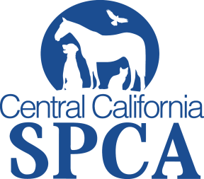 Media Contact:
Walter Salvari, CCSPCA Spokesperson
(559) 389-6224
media@ccspca.com
Press Release
June 21, 2014
WHO: Central California Society for the Prevention of Cruelty to Animals
WHAT: The CCSPCA is pleased to announce a reduction in Reclaim Fees during the July 4th holiday time frame. An impounded stray dog may be returned to the owner for one of the following fees:
- $12 license fee for an altered dog with all other fees waived, or
- $50 license fee on an unaltered dog with all other fees waived, or
- May surrender the unaltered dog to the CCSPCA at no charge, then adopt the dog for the current promotional fee of $28.80 and receive a licensed and altered dog.
WHEN: June 23 to July 13, 2014
WHERE: CCSPCA 103 S. Hughes Ave, Fresno CA 93706
WHY: More pets become lost during the July 4th holiday than any other time of the year. Our goal is to reunite you with your lost family member as quickly as possible at a reduced fee. So please check our lost & found page on our website and come to our Stray Animal Building if your pet is missing.
The CCSPCA is setting the goal of saving over 2,880 pets this summer during the ASPCA Rachel Ray 100K Challenge from June 1 through August 31.

#100KChallenge #SaveALifeFresno

For more information please contact
CCSPCA at 559.233.7722 ext 107 or visit ccspca.com
Central California SPCA, 103 S. Hughes Ave., Fresno CA 93706
###

